A123A-ME-Israel-‘Ubeidiya-Figurine-Silicified Sandstone-Lower Paleolithic-1.2 mya

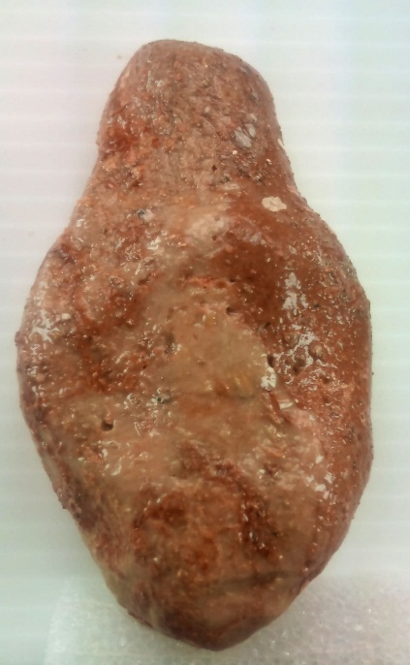 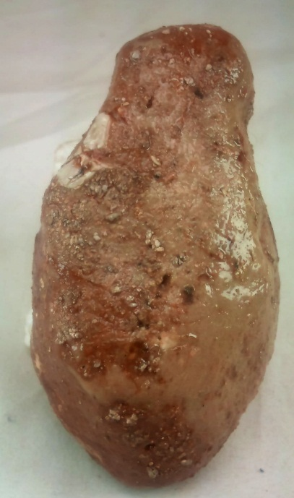 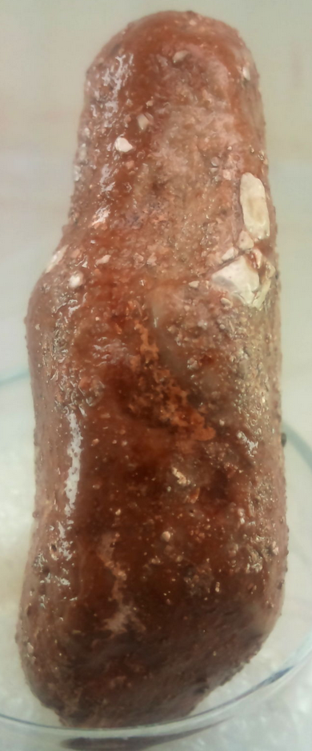 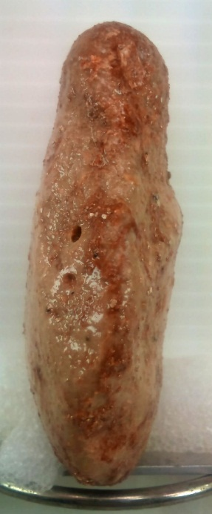

Figs. 1-4.Israel-‘Ubeidiya-Figurine-Silicified Sandstone-Lower Paleolithic-1.2 mya

**Case no.: 1**

**Accession Number:**

**Formal Label:** Israel-‘Ubeidiya-Figurine-Silicified Sandstone-Lower Paleolithic-1.2 mya

**Display Description:**

“The discovery is exciting by any standard. Was found to the north of the Dead Sea about 15 km from its right [bank]. In a cave in which an archaeological excavation is carried out. Dating to the beginning of the Paleolithic Stone Age. There are several figures engraved on it.” A product of *Homo Erectus*.

Lower Paleolithic hominin sites in the Levant include 1. Yabrud. 2. El Kowm. 3. Umm El Tlel. 4. Hummal. 5. Tabun cave. 6. Azraq sites. 7. Latamne. 8. Kefar Menachem West. 9. Revadim. 10. Holon. 11. Bizat Ruhama. 12. Nahal Hesi. 13. Kisufim. 14. Evron. 15. Ubeidiya. 16. Gesher Benot Yaakov. 17. Berekhat Ram. 18. Umm Qatafa. 19. Nahal Zihor. 20. Qesem Cave; Eyal 23. 21. Adlun cave sites: Bezez. Adlun and Abri Zumoffen caves (See Fig. ).

The Lower Paleolithic site of ‘Ubeidiya at ~1.4 Ma in the Jordan Rift Valley is in the area where this worked stone originated. The site provides evidence for the earliest migration of Homo erectus out of Africa (Belmaker et al. 2002; Martínez-Navarro et al. 2009). The Zihor River valley was surveyed in 1996 by H. Ginat and I. Saragusti of the Hebrew University, which uncovered an early sequence of Pleistocene fluvio-lacustrine deposits and a paleo “Lake Zihor” with a minimum date of ~1.6 Ma for the fluvio-lacustrine deposits (Guralnik et al. 2010). The gradual formation of valleys and terraces in the southern Negev (Ginat 1997: 188) were created by tectonic uplifting, post-dating Lake Zihor (Ginat et al. 2003). Lower Paleolithic Acheulean hand axes and worked stones like this one were concentrated in many find spots near the paleo shoreline of Lake Zihor and neighboring terraces in an area of 12km2 (Ginat 1997; 2003: 450).

**LC Classification:** [GN772.32.I75](http://josiah.brown.edu/search~S7?/c1-SIZE+GN772.32.I75+S27x+2004/cgn++772.32+i75+s27+x+2004/-3,-1,,E/browse)

**Date or Time Horizon:** Paleolithic 1.2 mya

**Geographical Area:** right bank of Jordan River near ‘Ubeidiya

### Map:

### 

Fig. 5. Map of Lower Paleolithic sites in the Levant: 1. Yabrud. 2. El Kowm. 3. Umm El Tlel. 4. Hummal. 5. Tabun cave. 6. Azraq sites. 7. Latamne. 8. Kefar Menachem West. 9. Revadim. 10. Holon. 11. Bizat Ruhama. 12. Nahal Hesi. 13. Kisufim. 14. Evron Quarry. 15. Ubeidiya. 16. Gesher Benot Yaakov. 17. Berekhat Ram. 18. Umm Qatafa. 19. Nahal Zihor. 20. Qesem Cave; Eyal 23. 21. Adlun cave sites: Bezez. Adlun and Abri Zumoffen caves.

### 

Fig. 6. Location of Ubeidiya after <https://upload.wikimedia.org/wikipedia/commons/thumb/a/a4/>

Israel_outline_northeast.png/375px-Israel_outline_northeast.png

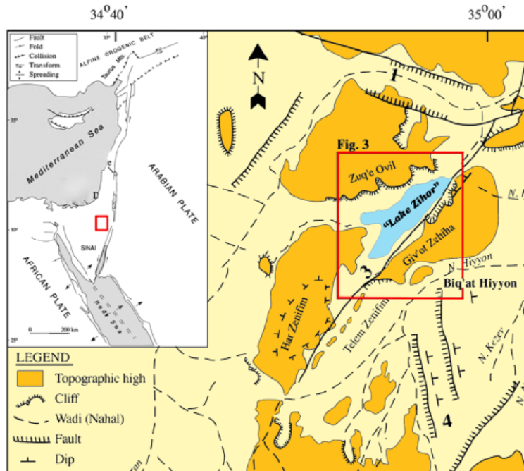 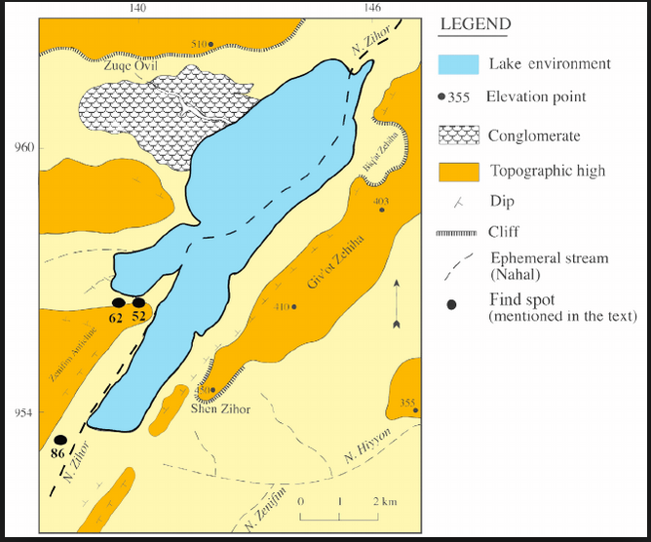

Figs. 7-8. Location of ’Ubeidiya in its geological setting (no. 62) in right map. After https://www.researchgate.net/profile/Leore_Grosman/publication/233859889/figure/fig1/AS:299980108648450@1448532239685/Location-of-the-Pleistocene-lake-Zihor-in-the-Arava-region-Southern-Israel-after-Ginat.png

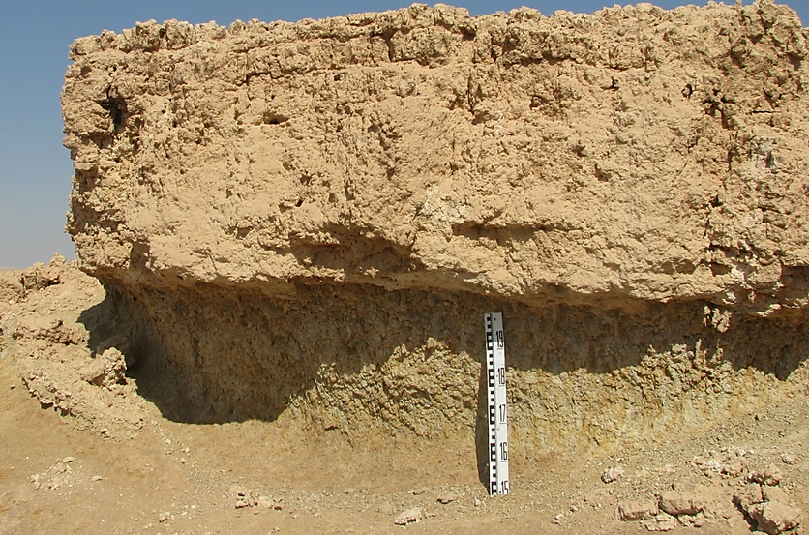

Fig. 9. Type of terrain in the Zihor River valley in which the artifact was found. From the research Reconstructing the Paleo Geohydrological aspects of the Early Pleistocene water body at Nahal Zihor (led by Yuval Lorig; co-supervised by [Hanan Ginat​](http://www.adssc.org/reserchers/דר-חנן-גינת)). After http://in.bgu.ac.il/en/humsos/fluv/images/zihor1.jpg

**GPS coordinates:** unknown

**Cultural Affiliation:** Paleolithic

**Medium:** silicified sandstone

**Dimensions:** H 7.6 cm; W 4 cm

**Weight:** 103 grams; 3.55 oz

**Condition: “**The stone was cleaned professionally by the archaeological team, and then coated with a transparent lacquer that gives it protection and custody as well as beauty for display. This is the standard treatment offered by the museum and carried out by those who are involved in it and at a high level.”

**Provenance:** Zihor River valley

**Discussion:**

“The incision of the present channel of Nahal (wadi) Zihor in the lacustrine sediments is manifested by a series of rock-cut and fluvial terraces (Q1–Q4) capped by gypsic-salic soils, which reflect the onset of the present, extremely arid climate. Over 100 find-spots and larger occurrences of prehistoric artifacts assigned to the Lower Paleolithic were discovered near Lake Zihor. On the basis of techno-typological and stratigraphic considerations, these assemblages are divided into two groups, the first of which may be contemporaneous with the lake, while the second is found mainly on the younger Q1 and Q2 terraces. It is estimated that the lake existed for more than 100,000 years” (Ginat, Zilberman, and Saragusti 2003).

**References:**

Archer, W. and Braun, D.R. 2010. Variability in bifacial technology at Elandsfontein, Western cape, South Africa: a geometric morphometric approach. Journal of Archaeological Science 37, 201–209.

Bar-Yosef, O. and Goren-Inbar, N. 1993. The Lithic Assemblages of Ubeidiya: A Lower Palaeolithic Site in the Jordan Valley. The Hebrew University of Jerusalem, Jerusalem.

Belmaker, M., Tchernov, E., Condemi, S., and Bar-Yosef, O. 2002. New evidence for hominid presence in the Lower Pleistocene of the Southern Levant. Journal of Human Evolution 43, 43–56.

Bordes, F. 1961. Typologie du paléolithique ancien et moyen. Imprimeries Delmas, Bordeaux.

Crompton, R.H. and Gowle, J.A.J. 1993. Allometry and multidimensional form in Acheulean bifaces from Kilombe, Kenya. Journal of Human Evolution 25, 175–99.

Gilead, D. 1970. Handaxe Industries in Israel and the Near East. World Archaeology 2, 1–11.

Ginat, H. 1997. Paleogeography and landscape evolution of the Nahal Hiyyon and Nahal Zihor basins (sedimentology, climatic and tectonic aspects). Geological Survey of Israel Report GSI/19/97, 206 (in Hebrew, English abstract).

Ginat, H., Zilberman, E. and Saragusti, I., 2003. Early pleistocene lake deposits and Lower Paleolithic finds in Nahal (wadi) Zihor, Southern Negev desert, Israel. *Quaternary Research*, *59*(3), pp.445-458.

Goren-Inbar, N. 1995. The Lower Paleolithic of Israel. In The archaeology of society in the Holy Land, Levy, T.E. (ed.). Continuum International Publishing Group, New York, pp. 93–109.

Goren-Inbar, N. and Saragusti, I. 1996. An Acheulian biface assemblage from Gesher Benot Ya’aqov, Israel: Indications of African anities. Journal of Field Archaeology 23, 15–30.

Goren-Inbar, N., Feibel, C.S., Verosub, K., Melamed, Y., Kislev, M. E., Tchernov, E., and Saragusti, I. 2000. Pleistocene Milestones on the Out-of-Africa Corridor at Gesher Benot Ya’aqov, Israel. Science 289, 944–947.

Gowle, L.A.J. and Crompton, R.H. 1994. Kariandusi: Acheulean morphology and the question of allometry. The African Archaeological Review 12, 2–42.

Grosman, L., Smikt, O., and Smilansky, O. 2008. On the application of 3-D scanning technology for the documentation and typology of lithic artifacts. Journal of Archaeological Science 35, 3101–3110.

Grosman L, Sharon G, Goldman-Neuman T, Smikt O, Smilansky U. Studying post depositional damage on Acheulian bifaces using 3-D scanning. Journal of Human Evolution. 2011 Apr 1;60(4):398-406.

Guralnik, B., Matmon, A., Avni, Y., and Fink. D. 2010. 10 Be exposure ages of ancient desert pavements reveal Quaternary evolution of the Dead Sea drainage basin and rift margin tilting. Earth and Planetary Science 290, 132–141.

Hardaker, T., and Dunn, S. 2005. The Flip Test - a new statistical measure for quantifying symmetry in stone tools. Antiquity 79, 306–307.

Howard, C.D. 2002. The gloss patination of flint artifacts. Plains Anthropologist 47, 283–287.

Jones, P.R. 1980. Experimental butchery with modern stones and its relevance for Palaeolithic archaeology.

World Archaeology 12, 153–165.

Jackson, J.E. 1991. A User’s Guide to Principal Components. John Wiley and Sons.

Jollie, I.T. 2002. Principal Component Analysis, 2nd edition. Springer Series in Statistics.

Kong, Y.K., and B.D. Lowe. 2005. Optimal cylindrical handle diameter for grip force tasks. International Journal of Industrial Ergonomics 35, 495–507.

Laukhin, S.A., Ronen. A., Pospelova, G.A., Sharonova, Z.V.,Ranov. V.A., Burdukiewicz, J.M., Volgina. V.A., and Tsatskin, A. 2001. New data on the geology and geochronology of the Lower Palaeolithic site Bizat Ruhama in the southern Levant. Paléorient 27, 69–80.

Liu, T. and Dorn, R.I. 1996. Understanding the spatial variability of environmental change in drylands with rock varnish microlaminations. Annals of the Association of American Geographers 86, 187–212.

Lyce, S. J. 2008. Acheulian variation and selection: does handaxe symmetry fit neutral expectations? Journal of

Archaeological Science 35, 2640–2648.

Machin, A.J., Hosfield, R.T., and Mithen, S.J. 2007. Why are some handaxes symmetrical? Testing the influence of handaxe morphology on butchery eectiveness. Journal of Archaeological Science 34, 883–893.

Martínez-Navarro, B., Belmaker, M., and Bar-Yosef., O. 2009. The large carnivores from ‘Ubeidiya (early Pleistocene, Israel): biochronological and biogeographical implications. Journal of Human Evolution 56, 514–524.

McPherron, S.P. 1999. Ovate and pointed handaxes assemblages: Two points make a line. Préhistoire Européenne 14, 9–32.

McPherron, S.P. 2006. What typology can tell us about Acheulian handaxe production. In Axe Age: Acheulian tool-making from quarry to discard, N. Goren-Inbar and G. Sharon (eds.). Equinox, London, pp. 267–286.

McNabb, J., Binyon, F., and Hazelwood, L. 2004. The large cutting tools from the South African Acheulean and the question of social traditions. Current Anthropology 45, 653–677.

Nowell, A.S. 2000. The archaeology of mind: standardization and symmetry in lithics and their implications for the study of the evolution of the human mind. Ph.D. dissertation. University of Pennsylvania, Philadelphia.

Purdy, B.A. 1975. Fractures for the archaeologist. In Lithic technology: making and using stone tools, Swanson, E. (ed.). Mouton Publishers, Paris, pp. 133–141.

Reneau, S.L., Raymond, R.J., and Harrington, C.D. 1992. Elemental relationships in rock varnish stratigraphic layers, Cima volcanic field, California: Implications for varnish development and the interpretation of varnish chemistry. American Journal of Science 292, 684–723.

Roe, D.A. 1964. The British Lower and Middle Paleolithic: some problems, methods of study and preliminary results. Proceedings of the Prehistoric Society 30, 245–267.

Roe, D.A. 1968. British Lower and Middle Palaeolithic Handaxe Groups. Proceedings of the Prehistoric Society 34, 1–82.

Ron, H., Porat, N., Ronen, A., Tchernov, E., and Horwitz, L.K. 2003. Magnetostratigraphy of the Evron Member—implications for the age of the Middle Acheulian site of Evron Quarry. Journal of Human Evolution 44, 633–639.

Saragusti, I. 2002. Changes in the morphology of handaxes from Lower Paleolithic assemblages in Israel. Ph.D. Dissertation. The Hebrew University Jerusalem, Jerusalem.

Saragusti, I., Karasik, A., Sharon, I., and Smilansky, U. 2005. Quantitative analysis of shape aributes based on contours and section proles in archaeological research. Journal of Archaeological Science 32, 841–53.

Saragusti, I., Sharon, I., Kaenelson, O., and Avnir, D. 1998. Quantitative analysis of the symmetry of artifacts: Lower Paleolithic handaxes. Journal of Archaeological Science 25, 817–825.

Sharon, G. 2007. Acheulian large flake industries: Technology, chronology and significance. British Archaeological Reports International Series 1701. Archaeopress, Oxford.

Soressi, M. and Dibble, H.L. (eds.). 2003. Multiple approaches to the study of bifacial technologies. University of Pennsylvania Museum of Archaeology and Anthropology, Philadelphia.

Susman, R.L. 1994. Fossil evidence for early hominid tool use. Science 265, 1570–1573.

White, M. 1995. Raw materials and biface variability in Southern Britain: a preliminary examination. Lithics 15, 1–20.